The Seventh Framework Programme for research and technological development (FP7)
Cooperation and funding opportunities in Environment



24-25 NOVEMBER 2010

Please insert the address

The two days training is targeted at those who never participated in FP7; offering an introduction to FP7 and outlining how to begin participating. The course includes practical activities and exercises to better understand FP7 mechanism and rules of participation.

Topics: Structure of FP7, where to find the information, how to apply, financial rules, partnership building.

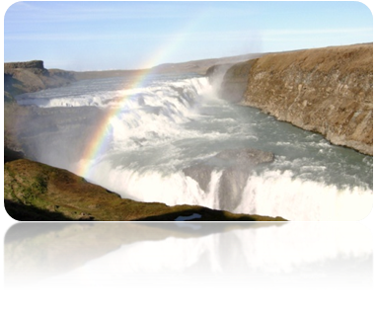

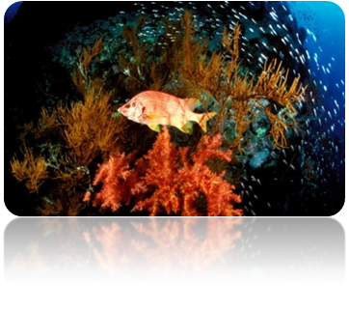

Agenda

24.11.2010

TIME | THEME | SPEAKER
14.00 | Registration
14.30 | Welcome  Participants introduce themselves
15.00 | The 7th Framework Programme (FP7): opportunities for Russian researchers  EU-Russia S&T cooperation  International cooperation in FP7 | To be defined
16.00 | FP7 – rules of game for Russian participants  FP7 eligible countries  Rules of Participation for partners from third countries in different project types | To be defined
17.00 | Partner search: tools for Russian participants | To be defined

25.11.2010

TIME | THEME | SPEAKER
9.30 | FP7 – “Environment including climate change”  General overview, Work Programme: research areas, How to deal with Call fiche. | To be defined
10.00 | Project proposal writing  Partnership,Structure of part B, Work plan | To be defined
11.00 | Proposal Evaluation: Rules and Procedures | To be defined
11.30 | Coffee break
12.00 | Proposal lab: practical exercise on how to write a project | To be defined
13.30 | Lunch break
14.30 | Presentation of the proposals, evaluation and dicussion | To be defined

